General File locations for ASCOM Gemini Telescope Net Install

The install of this driver requires that the ASCOM 5.0a Platform be installed.
This software can be downloaded and installed from:
http://ascom-standards.org/Downloads/Index.htm
The download link is on the right side of the page.

After installing the above package you will need to download and install an update to the above package. This update is in the files section of the ASCOM_Talk group.
http://tech.groups.yahoo.com/group/ASCOM-Talk/files/Platform%205.5%20Updater/
.
You also need to have Windows Net 3.5 SP1 Installed. See
http://www.microsoft.com/downloads/details.aspx?familyid=AB99342F-5D1A-413D-8319-81DA479AB0D7&displaylang=en
or for a shorter link http://tinyurl.com/5m4j75

It should have a name of Platform 5.5 Updater, with a description of
Platform 5 Updater Release Candidate.
The current version as the writing of this document is:
ASCOM Platform 5.5 Updater RC3 (v5.5.6.11).exe.

Please download it to a location on your hard drive. I suggest creating a directory
C:\ASCOM Driver Install. Then store the installation files in that subdirectory.
If using Vista or Win7 please right click on the file and use “Run as administrator” Please accept all the default install values.

If you get any error messages, please use “Alt PrtScn” (or the snipping tool in Vista and Win7) to copy the error message into a WordPad file and save it as a .rtf file. Please post a message in the user group and post the rtf file under Log and Error Files. Please create a subdirectory with your name, and then create a second subdirectory under your name with the date of the error files. If you port more files later on that has a different date, please create a subdirectory with that date under your name. You can see examples of these file structure below:
Log and error Files
Files from Tom Hilton ← new subdirectory
10-10-2009 ← new subdirectory
Log.rtf ← example of file you want to post. (you may also zip them if there are more than one.

Installing The Gemini Driver

Next you will need to install the Gemini Driver. You will find this in the files section of this users group. It will be name something like:
GeminiTelescopeInstaller(1.0.x.x).exe
The current version as of the writing of this document is “GeminiTelescopeInstaller(1.0.23.6).exe “
This filename subject to change, as updates are added..

Please download it to the same directory as you downloaded the previous file.
Please run the file. If using Vista or Win7 please install as an administrator, by right clicking on the file name and select run as administrator.

If you receive any error messages, please follow the above procedures, as stated on page 1.

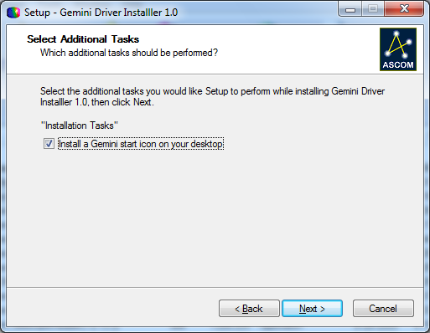
When you see the below message, please DO-NOT DESELECT the “Install a Gemini Icon on your desktop.

If you have a version of the Gemini.net driver already installed, this driver will give a message that it is removing the old driver. It however will leave previous your setting in tack.
MENU Selection and locations.

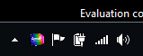

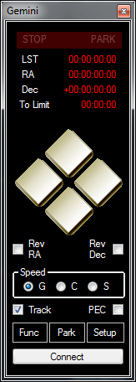
After you have installed the Gemini Driver, there will be a Gemini Icon on your desktop. If you click this, you will then see the Gemini Control panel displayed to the far left on your pc screen. Also a Gemini Icon is placed in your task bar. This Icon in your taskbar is the main place to pull up the other menus from. This is especially true If the other menus become hidden. You can either mouse over it, or right click on it to get a full menu selection in the lower right of your screen.

When you mouse-over this icon, a window will popup showing the loaded Gemini parameters. All these will be null until the Gemini is connected.

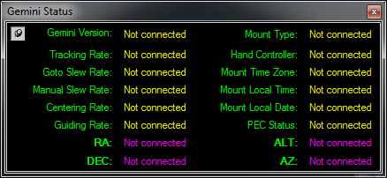
The above menu is displayed on a mouse over of the Gemini Icon in the taskbar. It how has a pin-lock to hold it in place. This is located in the upper left corner.
Status will be empty until the Gemini is connected.
The Park Menu
The park menu will bring up several options:
- Park
- Park at startup position (CWD)
- Park at Home position
- Part at current position
- Unpark
- Configure Driver Park Position. ← This has a menu of it’s own
As shown below.
.
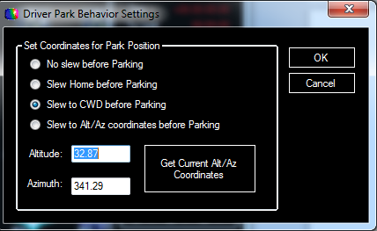

This menu will set the action to perform is a default Park command is issued.

Setup Menu

Clicking on the SETUP button at the bottom of the Gemini controller menu will bring up the following menus.
- Configure Telescope. -- This is where you will set up the com ports.
- Configure Focuser -- This is the focuser setup menu
- Advanced Gemini Setting – this is where you will set most of the Gemini’s setting
- Observatory Log – displays the log from the Gemini of observing actions.
- Manage Catalogs – where you can manage/add and edit Gemini catalogs
- About Gemini Driver – credit page.
- EXIT – this is where you will terminate the Gemini driver.
NOTE that all these same menus can be selected by right clicking on the Gemini Icon in the Task Bar.

Configure Telescope Menu

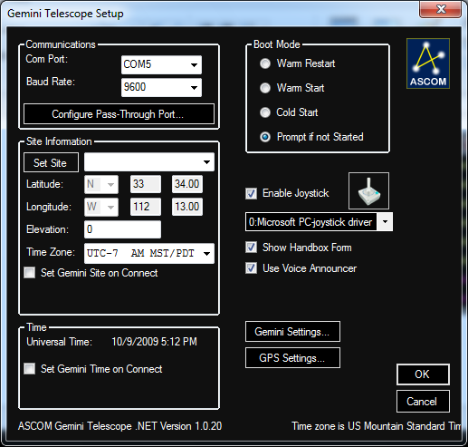
This is the configure telescope menu.
Communications Menus
This menu will allow you to setup the Communications port for using the Gemini driver.
There are 3 com ports menus available.
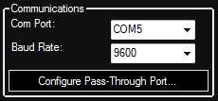
The first is the Gemini port and baud rate. Use this to select which port your Gemini is connected to and it’s baud rate. The driver will autoscan if it does not find the Gemini at this port.

The next is the PASS-Through Port. I will not get into this until later, as these is a very advanced Option of this driver.

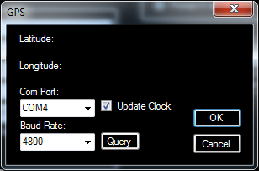
The next is the GPS setting menu. Use this port to select a GPS that you may have connected to one of the serial ports or USB port of your PC. If using a USB version, it’s driver must emulate a serial port for this
GPS function to find it. Also it must be
NEMA 0183 compatible. You can have it update the PC clock automatically by clicking on the Update Clock check box.
Once a Baud rate and port number is selected, hit the Query for the unit to find and display the latitude and longitude. Note that 4800 baud is default for most GPS units.

BOOT MODE Selection

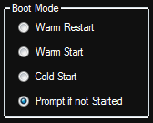
Use this menu to select the boot mode of the Gemini. If
Warm Restart, Warm Start or Cold Start is selected when
The Gemini is connected, The that mode will be used.
If Prompt is not Started is selected, then when the driver
Makes connection to the Gemini and determines if it has stated
or not. If the Gemini has not started, then it will prompt for the boot mode to use.

Advanced Telescope Setting Menu.
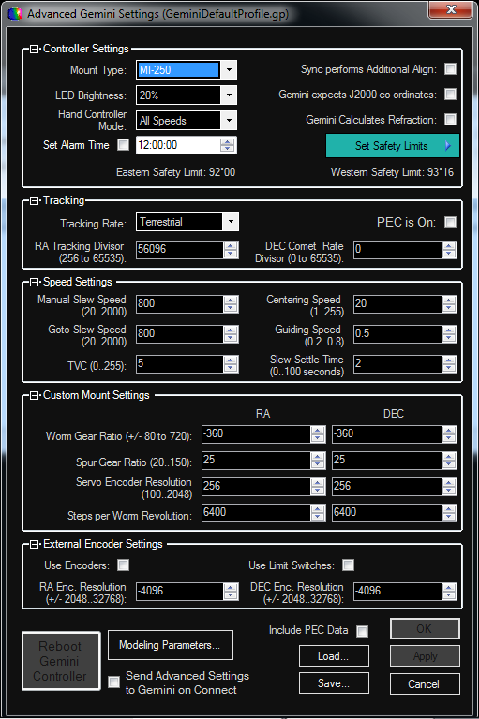
The new Gemini driver allows you to save and restore all of the important Gemini controller settings into a file. The way to do this is from the Advanced Settings window.
Connect to Gemini, and select Advanced Gemini Settings menu. The window will pop-up showing the all the current settings used by Gemini: in the title of the window you'll see "(settings from Gemini)".
You can then click on "Save…" button near the bottom, and all of the current settings will be saved in a file. If you name this file
GeminiDefaultProfile.gp, this settings from this file will be automatically sent to Gemini on start-up, if you also check the "Send Advanced Settings on connect" checkbox.
You can give a profile any name you like. You can have as many profiles saved, as you'd like. You can later load any of the saved profiles by using the "Load…" button.

Advanced Telescope Setting Menu.

Once loaded, all the settings from this profile can be sent to Gemini by clicking on the "Apply" button, or by hitting "OK". Note that you must be connected to Gemini for these two buttons to be available.
Here's a list of everything that is saved as part of the profile:
* All settings under Controller Settings, including safety limits
* All settings under Tracking
* All settings under Speed Settings
* Custom mount settings are used only if Mount Type is set to Custom
* All External Encoder settings
* All modeling parameters
* All of PEC programming, assuming "Include PEC Data" is checked
Note that once you load a different profile, the title of the Advanced Settings window will indicate the name of this profile (Profile092009-withPEC.gp) for example.
Once loaded, you can make changes to the profile, for example, selecting a different hand-controller mode, or different slewing speed. Once you make any desired changes, you can save the profile to a file (Save... button), or send it to Gemini (Apply button).
You can load, modify, and save back to a file any of the saved profiles even while Gemini is disconnected.
The idea of a Gemini profile is to store a complete state of the Gemini controller in a file that can be restored and modified later.
For example, if you save a profile, then remove the 3v CMOS backup battery causing a complete reset, and then load the saved profile and Apply it to Gemini, your Gemini will be restored back to exactly the state it was in before the reset.

Note: Do to limitations of the Gemini Firmware, If you remover the battery and then restore a profile, You will not be able to increase the modeling parameters using additional align. This is not caused by these driver, and functions the same way if using GCC or the old ASCOM Gemini driver to restore profiles.

Game Pad Interface

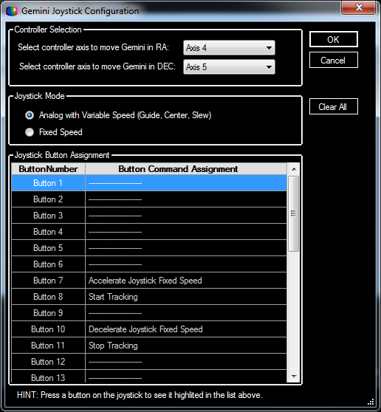
The Game pad menu allows to
to configure how the different controls and buttons will work with these Gemini Driver.
The settings show at left are for a Wingman Wireless Rumble pad controller.

The Axis selection for both RA and Dec let you assign there movement to one of the analog functions of the gamepad. In the case to the left, I had to use Axis 4 and 5 for the right stick.

The next selection down is either Analog with Variable Speed, or fixed speed.

If you select the Analog with Variable speed, then a small movement of the joystick should start you out in the Guide speed mode. Further movement of the same stick in the same direction should switch you to Center Speed, with still further movement accelerating to Slew Speed.

Now if you select Fixed Speed then the joysticks will move you at the speed you have selected on the Gemini Control menu. You can change these by assigning one of the buttons on the gamepad to do so. I have assigned Button 7 to Accelerate the Joystick speed, and button 10 to Decelerate the joystick speed.

While in the above menu, pressing any button on the joystick should make that button active by highlighting its position. If you take your mouse and point into this highlighted position, you will get a selection menu where you can assign one of the buttons to a fixed task,

PLEASE NOTE THAT IS DOCUMENT IS NOT FINISHED. THE PAGES THAT FOLLOW
ARE FOR ADDING FUTURE DOCUMENTATION TOO.
